**DIT092**

**Team name: Random Fantasy**

* Team members:

1. George Sarkisian: gussarksa@student.gu.se 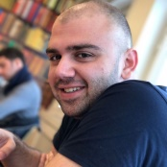
2. Albin Gustafson: gusgusal@student.gu.se 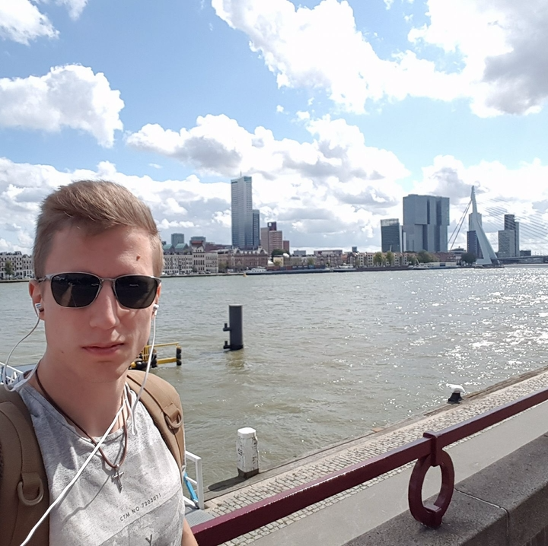
3. Kaijie Xiong: gusxioka@student.gu.se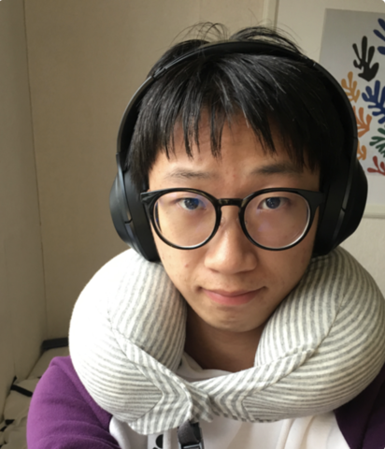
4. Fredrik Salmi: gussalmfr@student.gu.se 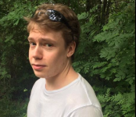
5. Haoyang lyu: guslyuha@student.gu.se 
6. Patrik Gardsten: gusgardpa@student.gu.se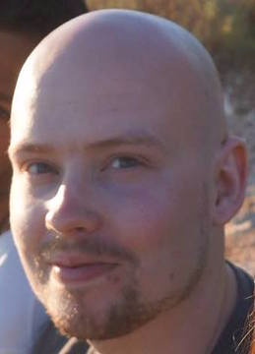

* Sit down and discuss how many hours a week you will work and on what days?

We are going to meet every Fridays and Mondays for 2 hours after lectures to synchronize our work, our main method of working will be individually.

* How does each of you look at this project? Are you in it to get a Pass, a high pass? To learn something specific?

All the members in the group are willing to get a high pass and we are willing to learn new skills like: GUI and working in group environment.

* How will you divide the workload between the team members? Are there certain skillsets that some team member possesses that should be used?

We are going to divide the task between team members equally and we are going to help each other to achieve our goals. Haoyang lyu is going help us with GUI.

* Will you work according to a specific methodology?

We are going to use agile methodology.

* We created Slack group, Trello and Gitlab. We posted the tasks in the Trello and devided the workload.

Best regards

Team Random Fantasy